**FastApi based App for Sentence correction**

**Purpose:** The purpose of this document is to help the programmer run the FastApi app and test out the predictions of the model first hand

**Steps for getting started:**

Sequentially Run all the code blocks. However, make sure that you are on track with the following steps to run the app successfully. We will also add few snapshots for ready reference

Step 1 – Pip install all the dependencies ([link](Notebook1%20link))

Step 2 – Mount the device to google docs and load the required pickle files ([link](https://colab.research.google.com/drive/12GKlgmHyfDRRI-0K2FTweQeNJjzm3kEf#scrollTo=avLp_tU3qBaw&line=2&uniqifier=1))

Step 3 – Run the Fastapi config specifically the function block ([link](https://colab.research.google.com/drive/12GKlgmHyfDRRI-0K2FTweQeNJjzm3kEf#scrollTo=gLESI_3BCPpA&line=1&uniqifier=1))

Step 4 – Run this code block to initiate the app on the server ([link](https://colab.research.google.com/drive/12GKlgmHyfDRRI-0K2FTweQeNJjzm3kEf#scrollTo=ftPVMj82CPaY&line=7&uniqifier=1))

**Steps to run the app on server:**

Step 1 – After Step 4 in prior process, you will be seeing a message like this. (Note – Public URL need not be the same). Kindly click the URL

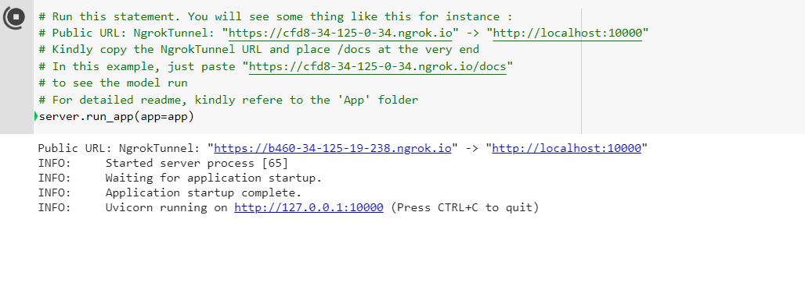

Step 2 – After clicking the URL, you will see a page opening like this. Kindly add docs to the URL.

**Example only:** The link we got in the prior step is https://b460-34-125-19-238.ngrok.io. Just add ‘/docs’ in the URL. The new URL will be <https://b460-34-125-19-238.ngrok.io/docs>

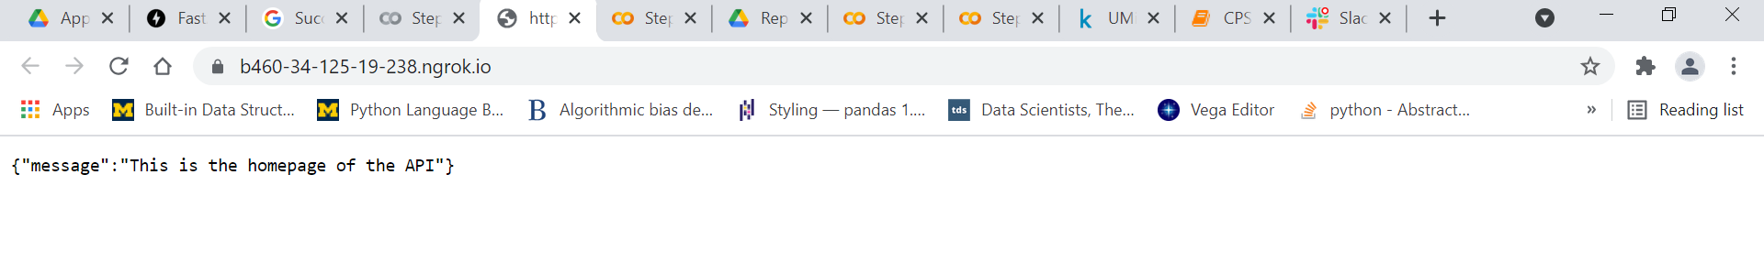

Step 3 – An interface like this opens up –

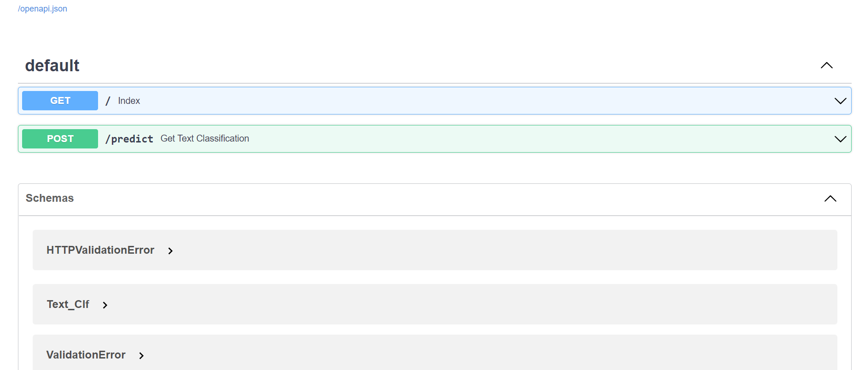

Kindly click Get Text Classification block. A page similar to this will appear

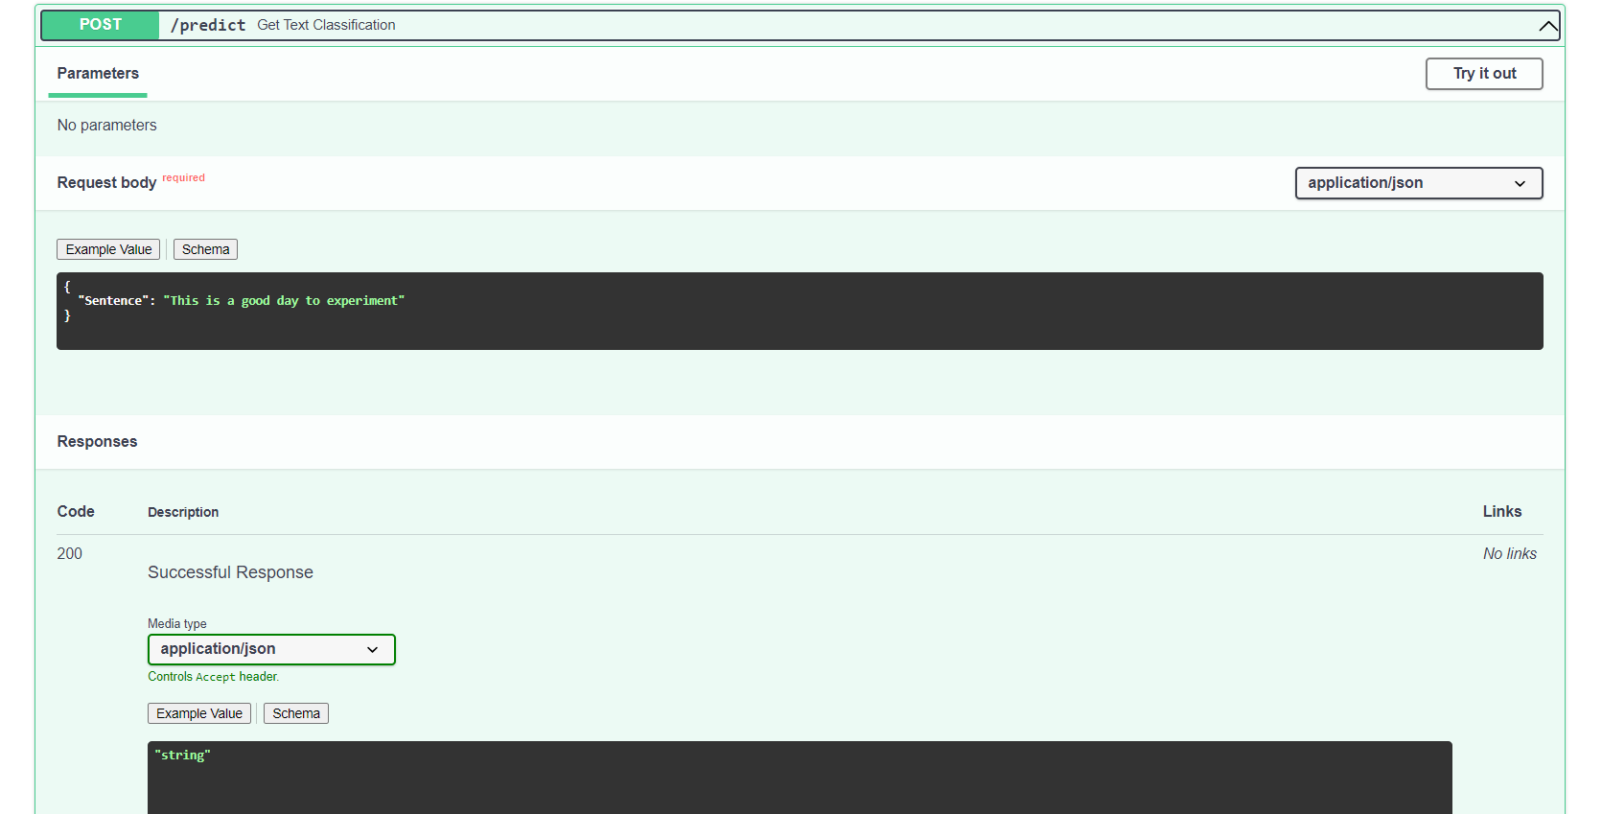

Step 4 – Click **Try it out** in thetop right side of the page. It will ask you to enter an example. We entered an example ‘This is a good day to experiment dont you think so?’

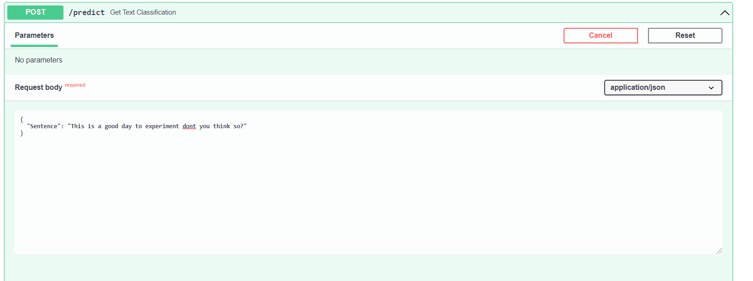

Step 5 – You can execute the program and the result will appear in the bottom half of the page –

